BUKTI KORESPONDENSI ARTIKEL

Judul Artikel | : | The Impact of Spiritual Emotional Freedom Technique (SEFT) on Adolescent Nicotine Dependence: A Quasi-Experimental Study
Jurnal | : | Poltekita: Jurnal Ilmu Kesehatan, Volume 19 Issued 3, 2025, Page 495-504, DOI: https://doi.org/10.33860/jik.v19i3.4289
Penulis | : | Linda, Idramsyah, Wisuda Andeka
Sitasi | : | Linda, L., idramsyah, I., & Marleni, W. A. (2025). The Impact of Spiritual Emotional Freedom Technique (SEFT) on Adolescent Nicotine Dependence: A Quasi-Experimental Study. Poltekita: Jurnal Ilmu Kesehatan, 19(3), 495–504. https://doi.org/10.33860/jik.v19i3.4289

Nama Proses Hal
1. Journal Identification 2
2. Submitted to the journal “Jurnal Ilmu Kesehatan” (18 Oct 2026, 07:08) 3
3. Manuscript Submitted (18 Oct 2026) 4
4. Editor's Decision: Revisions Required (02 Nov 2025, 20:14) 5
5. Comments and suggests (Major Revisions) from Reviewer 1 (24-Oct-2025) 7
6. Comments and suggests (Minor Revisions) from Reviewer 2 (29-Oct-2025) 8
7. Manuscript Revisions Process according the Comments and suggests from Reviewer (03 Nov-3 Dec-2025) 9
8. Tracking Changes: Comparison of the Manuscript from Initial Submission to Revised Version (3 Dec 2025) 10
9. Revision Summary for the Reviewer Comments (03 Dec 2025) 11
10. Turnitin Similarity Report Received (04 Dec 2025, 08:28) 12
11. Manuscript Resubmitted (05 Dec 2025) 13
12. Accepted for Publication and Funding Information Confirmation (10 Dec 2025, 09.01) 14
13. Payment Confirmation (10 Dec 2025, 10.01 15
14. Letter Of Acceptance (10 Dec 2025, 09:22) 16
15. APC Invoice (15 Dec 2025, 09:22) 17
16. Proofreading Confirmation Before Publication (15 Dec 2025, 09.33) 19
17. Gallay Proof Before Publication (15 Dec 2025, 09.33) 20
18. Final Proofreading Before Publication 21
19. Online Published (30 Dec 2025) 22

Journal Identification

The journal is accredited by SINTA (Science and Technology Index), the Indonesian National Journal Accreditation System, with a SINTA 2 ranking.
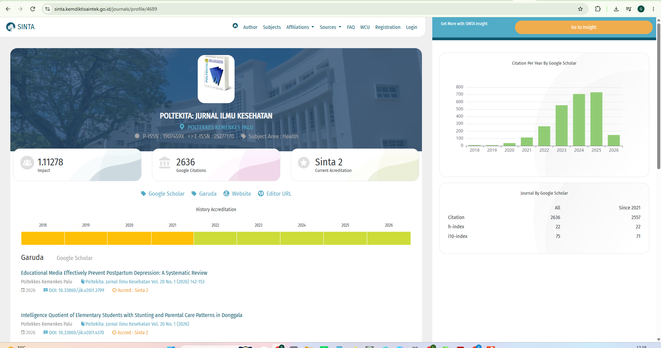
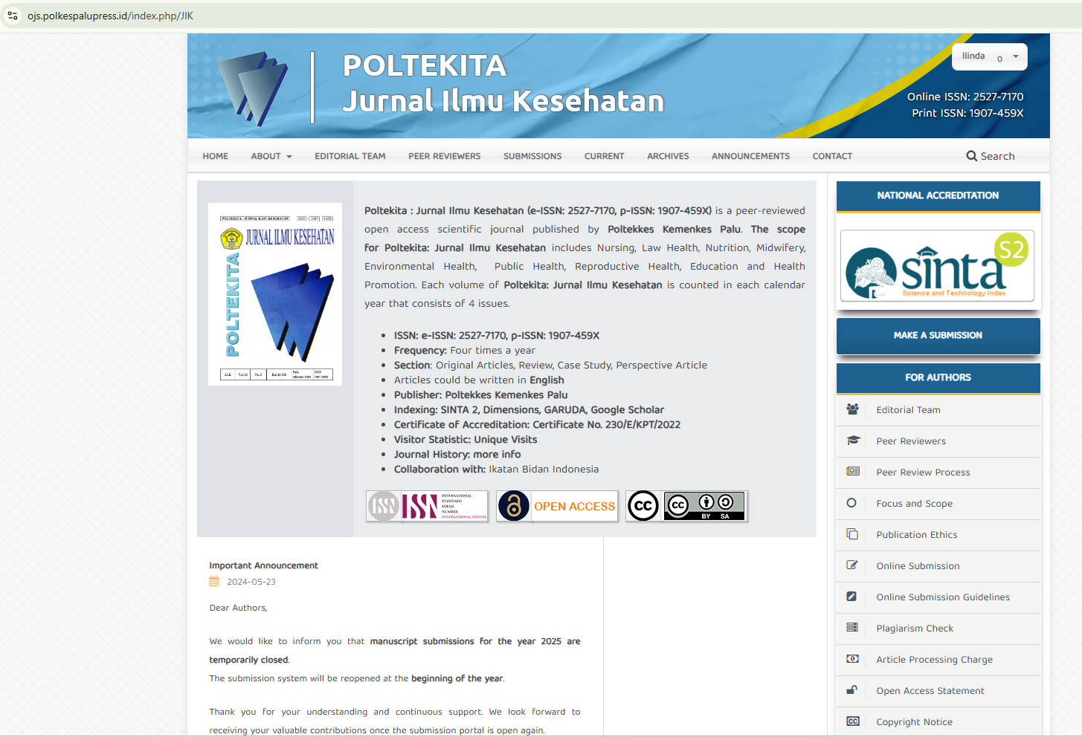
Journal Link: https://ojs.polkespalupress.id/index.php/JIK
Article Link: https://ojs.polkespalupress.id/index.php/JIK/article/view/4289

Submitted to the journal “Jurnal Ilmu Kesehatan” (18 Oct 2026, 07:08)
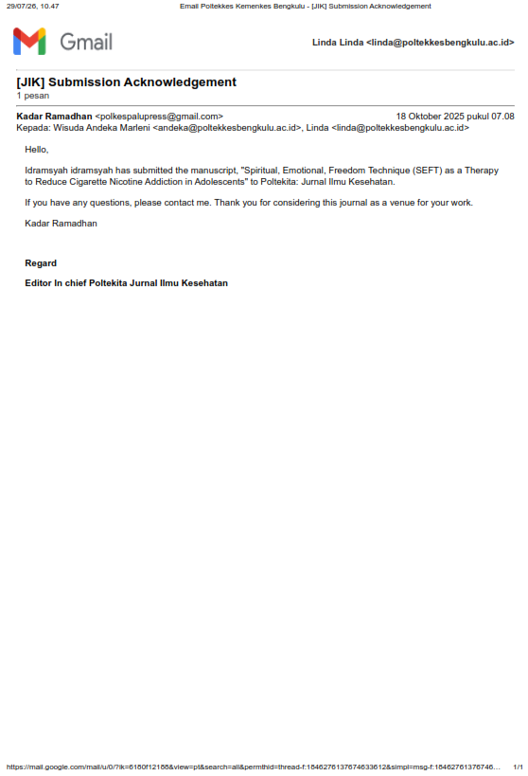

Manuscript Submitted (18 Oct 2026)
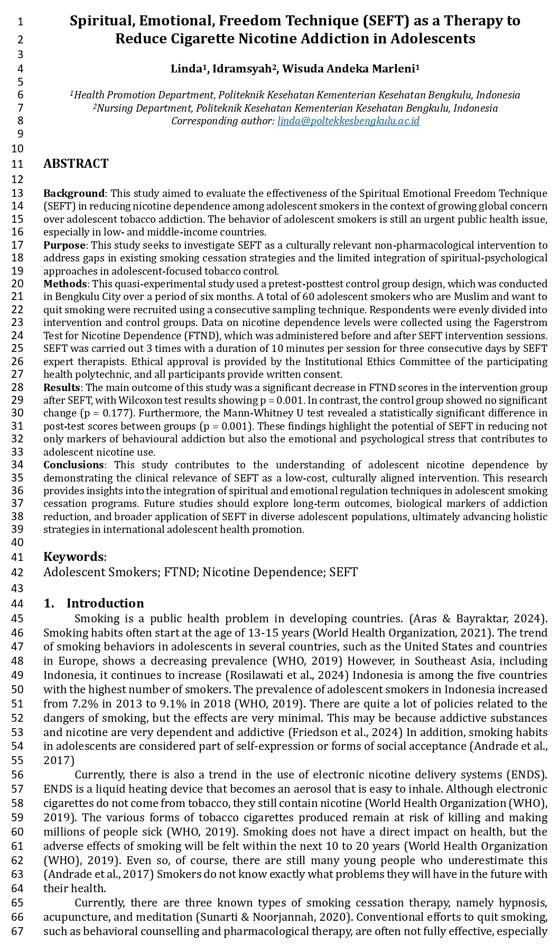

Editor's Decision: Revisions Required (02 Nov 2025, 20:14)
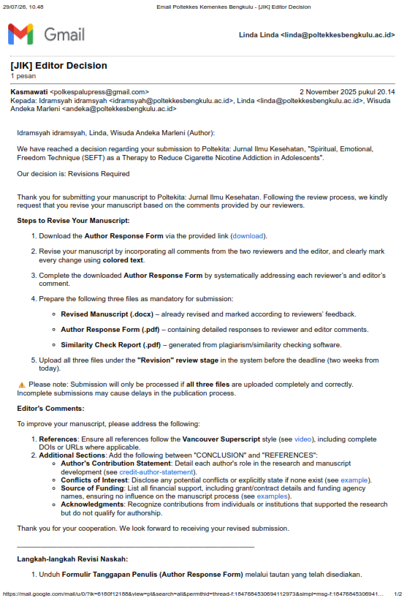

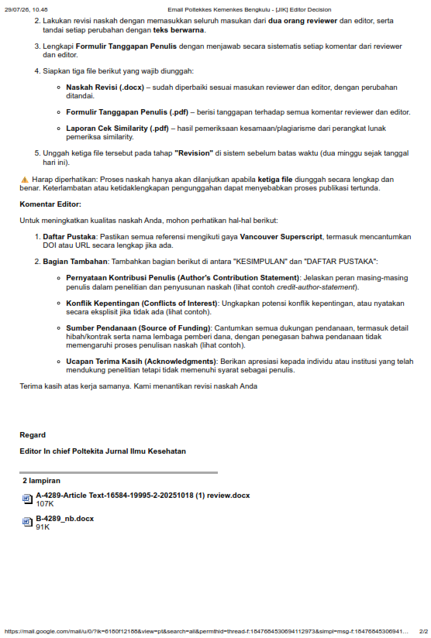

Comments and suggests (Major Revisions) from Reviewer 1 (24-Oct-2025)

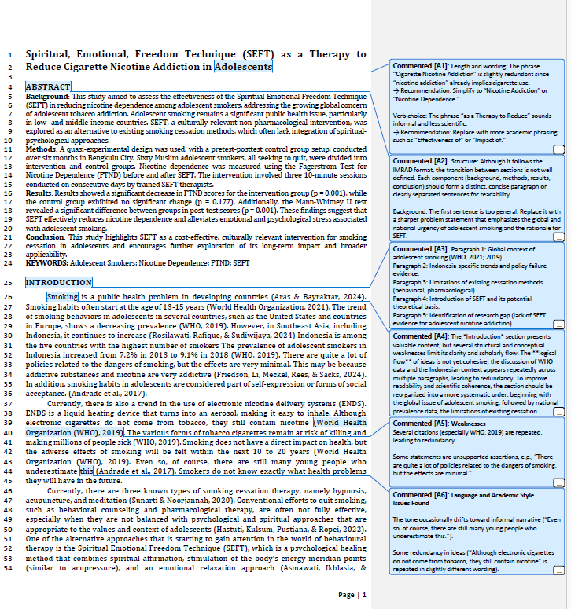

Comments and suggests (Minor Revisions) from Reviewer 2 (29-Oct-2025)
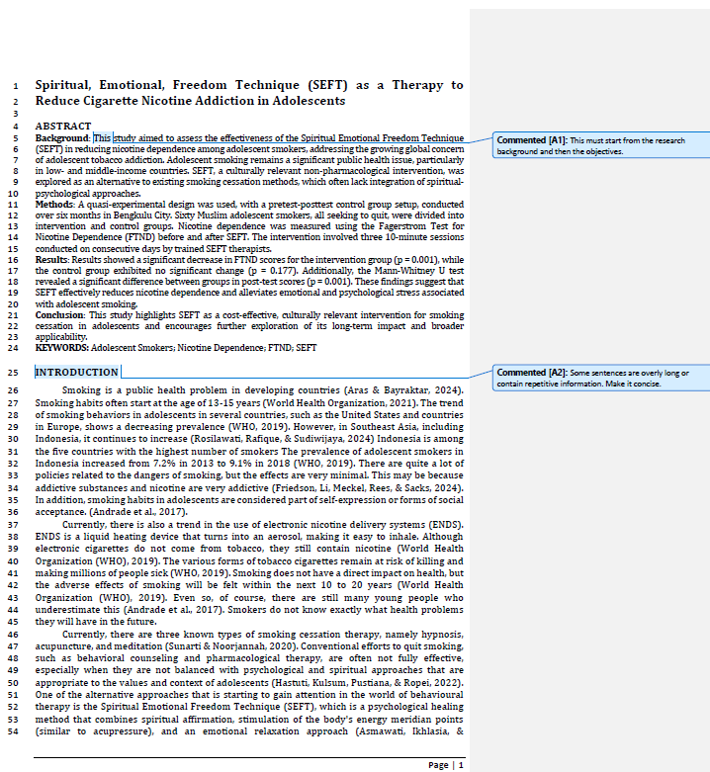

Manuscript Revisions Process according the Comments and suggests from Reviewer (03 Nov-3 Dec-2025)
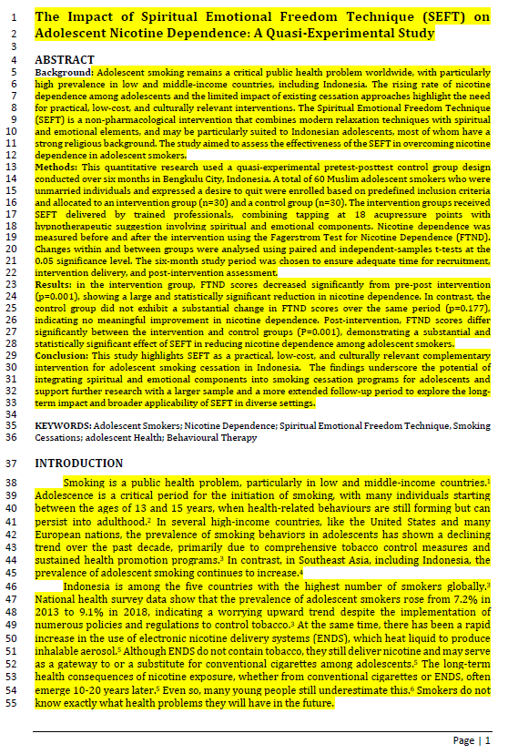

Tracking Changes: Comparison of the Manuscript from Initial Submission to Revised Version (3 Dec 2025)
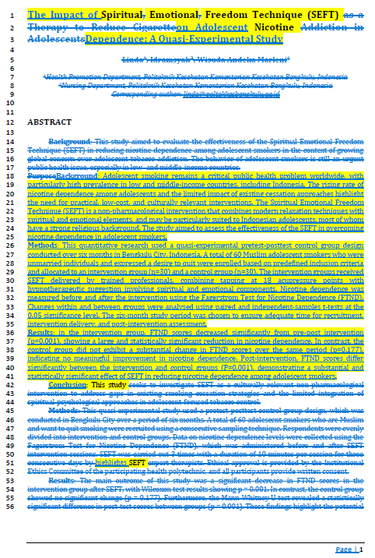

Revision Summary for the Reviewer Comments (03 Dec 2025)
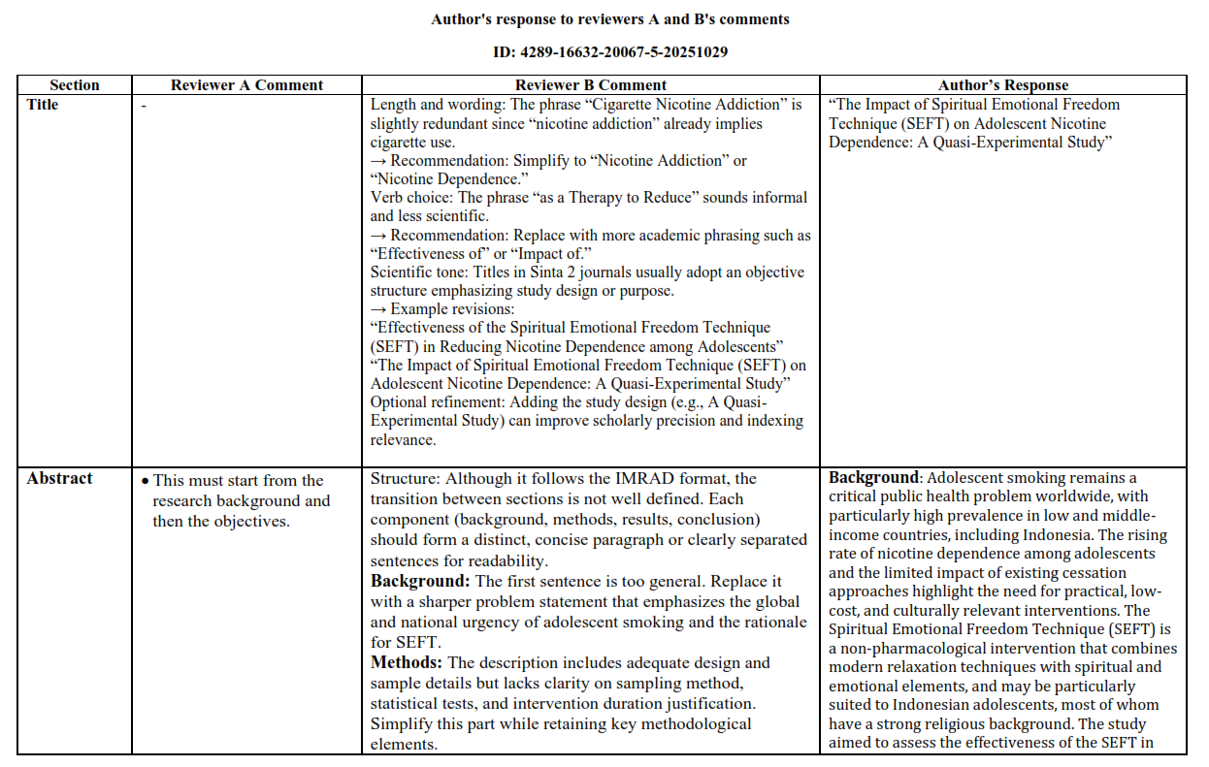
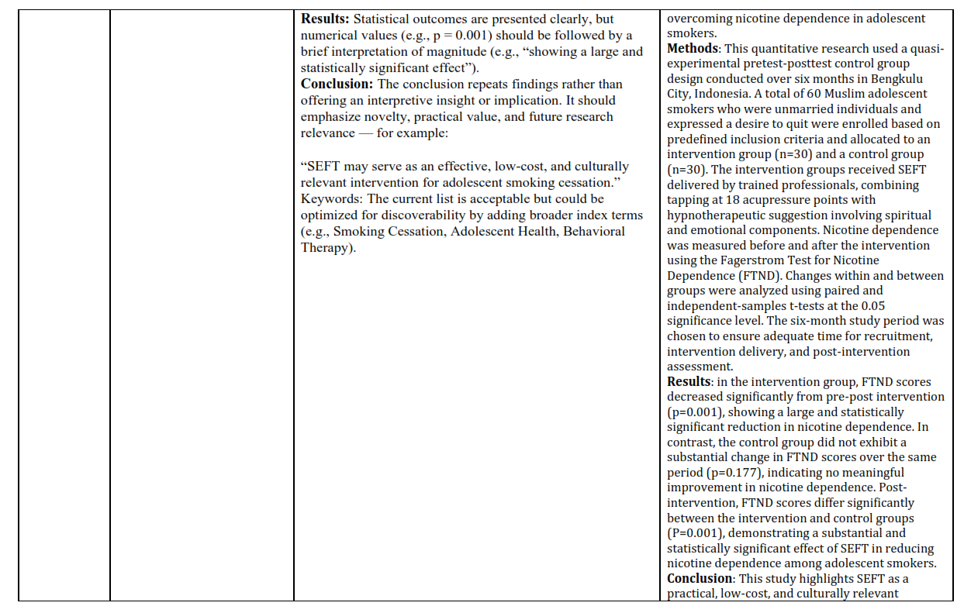

Turnitin Similarity Report Received (04 Dec 2025, 08:28)

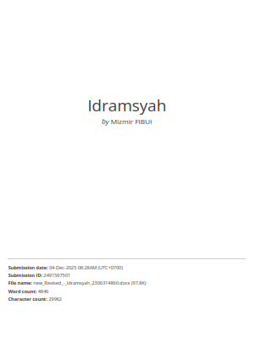

Manuscript Resubmitted (05 Dec 2025)

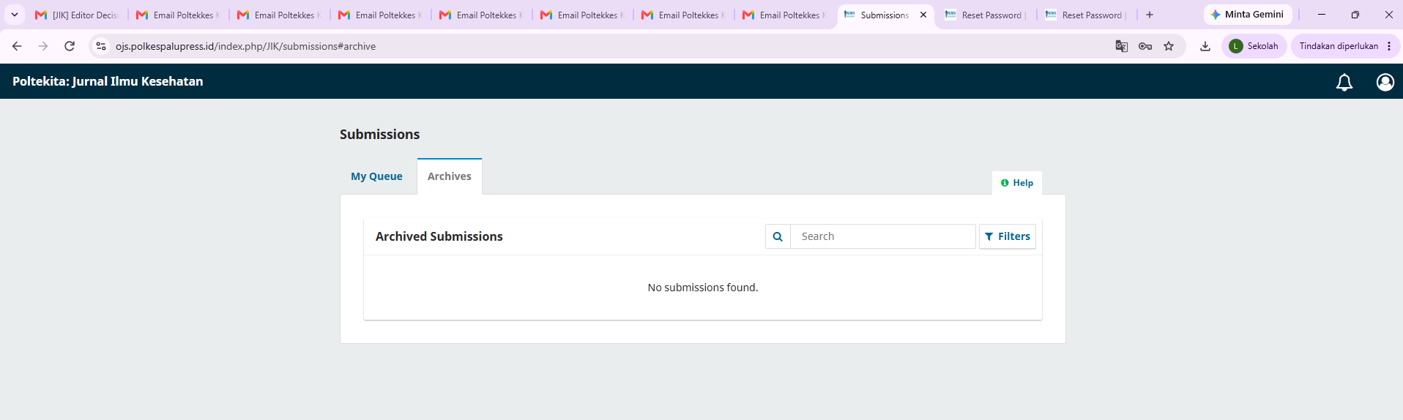

Due to technical issues affecting the Jurnal Ilmu Kesehatan journal's OJS platform, the submission history is no longer available in the system. In addition, no automated notification was generated by OJS following the resubmission process. Nevertheless, we can confirm that the manuscript was successfully resubmitted to the OJS system after the Turnitin similarity check was completed.

Accepted for Publication and Funding Information Confirmation (10 Dec 2025, 09.01)
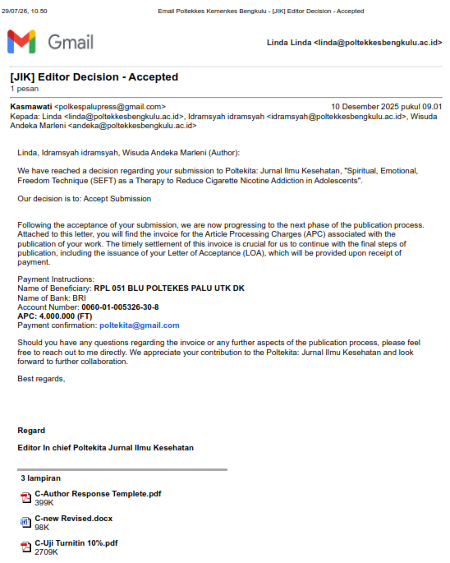

Payment Confirmation (10 Dec 2025, 10.01
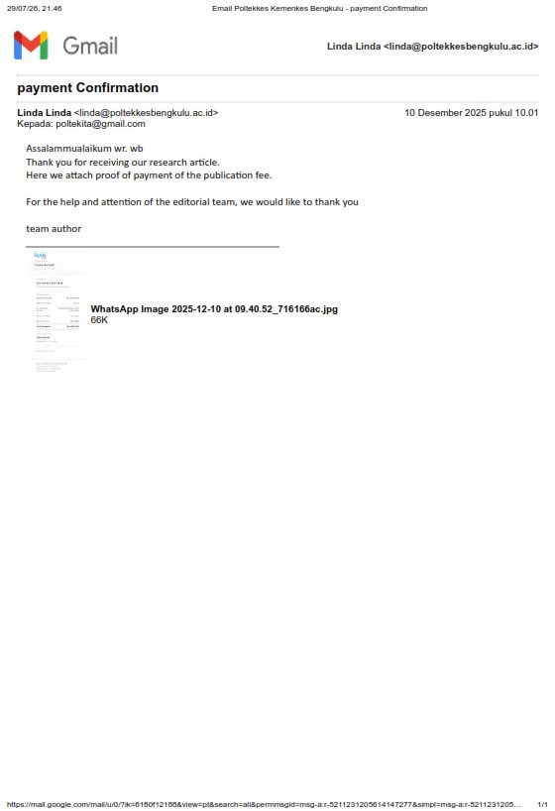

Letter Of Acceptance (10 Dec 2025, 09:22)
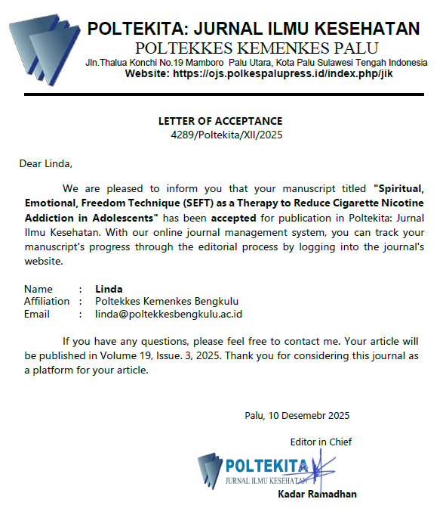

APC Invoice (15 Dec 2025, 09:22)
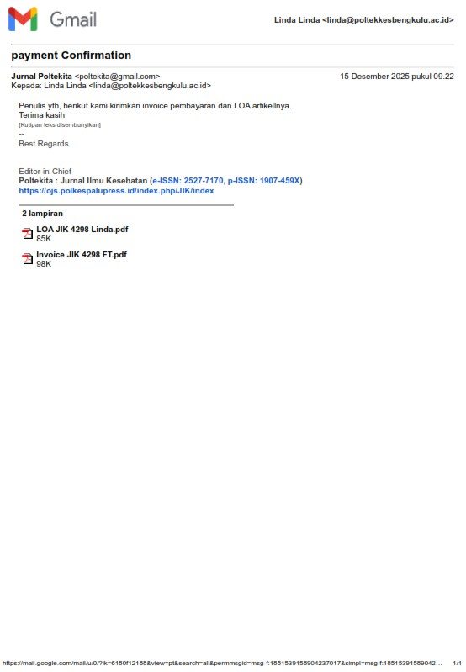

Proofreading Confirmation Before Publication (15 Dec 2025, 09.33)

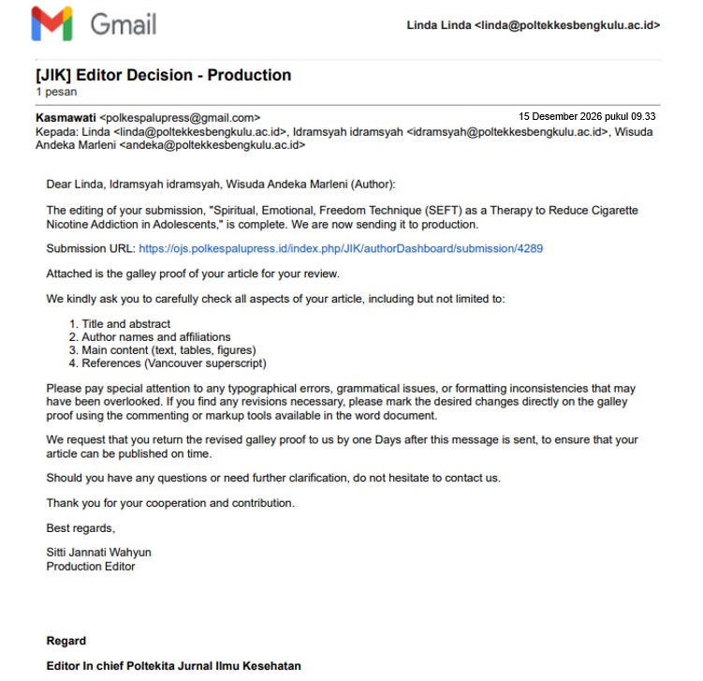

Gallay Proof Before Publication (15 Dec 2025, 09.33)

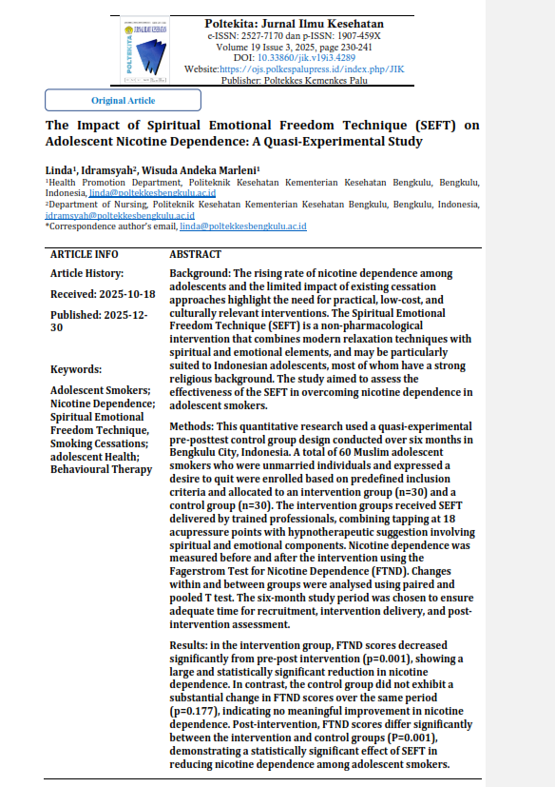

Final Proofreading Before Publication

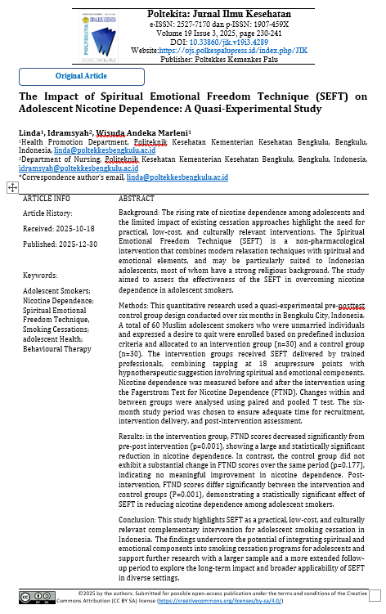

Online Published (30 Dec 2025)
